**Spot Speed Study**

Name: Khush Panchal Roll No. : 17CE10065

CE29003 – Transportation Engineering Lab

1. **PROBLEM STATEMENT**

* To determine whether the roadway is in need of new law enforcement, realignment, or reconstruction.
* For measuring effectiveness of traffic control devices or traffic programs, including signs and markings, traffic operational changes, and speed enforcement programs.
* To check whether rules are followed by people or not.

1. **OBJECTIVE:**

* To do survey and collect data of speed (using Laser Speed Gun) of different vehicles at the given location or spot.
* To plot the graph of vehicle speed to its frequency.

1. **INTRODUCTION:**

**SPOT SPEED STUDY-**

A spot speed study is performed by measuring the individual speeds of the vehicles passing through a given point (spot) on a street or highway. The speed characteristics of the sample are used to estimate the speed distribution of the entire traffic stream (the population) at that location under the conditions prevailing at the time of the study. Spot speed studies are undertaken for relatively short time periods; speed monitoring over extended periods, for the purpose for roadway surveillance and control, are not spot speed studies.

**APPLICATIONS OF SPOT SPEED-**

* Determining existing traffic operations evaluation of traffic control devices.
* Establishing roadway design elements.
* Assessing roadway safety questions.
* Monitoring traffic speed trends by systematic ongoing speed studies.
* Determining traffic signal timing, roadway capacity, evaluating the effectiveness of improvements, and installing speed zones.
* Measuring effectiveness of traffic control devices or traffic programs, including signs and markings, traffic operational changes, speed enforcement programs.
* Used to design the geometry of road like horizontal and vertical curves, super elevation etc. Location and size of signs, design of signals, safe speed, and speed zone determination, require the spot speed data. Accident analysis, road maintenance, and congestion are the modern fields of traffic engineer, which uses spot speed data as the basic input.

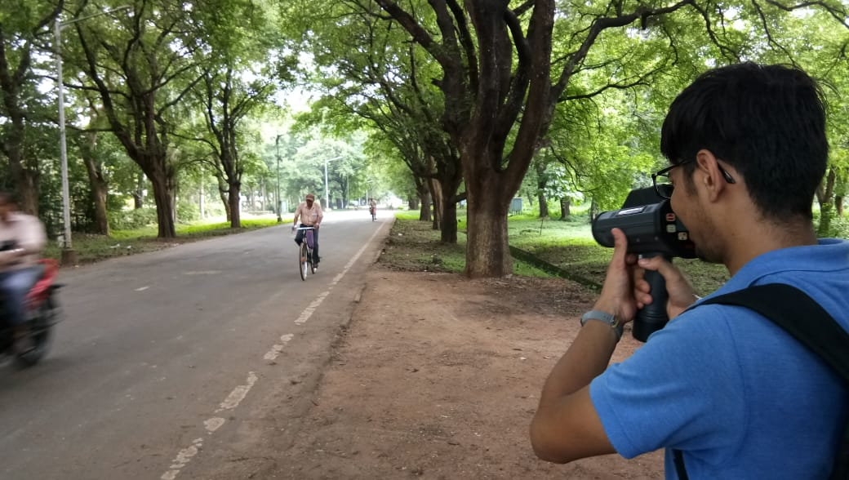

*(Measuring Spot Speed using Laser Speed Gun)*

1. **DATA COLLECTION:**

**STEPS REQUIRED TO PERFORM THE STUDY-**

1. Organize Study Plan –
   1. It is essential to identify the reason for conducting the study and the nature of the problem to be evaluated.
   2. The timing of the study should be consistent with the reason for conducting the study.
   3. Speed data should be collected for a minimum of one hour and should observe at least 30 vehicles.
2. Select Data Collection Method –
   1. Some of the methods used to collect Spot Speed Data:
      1. Stopwatch Method
      2. Radar Detectors/Speed Gun Method
      3. Pneumatic Road Tube Method
   2. This study was conducted using Laser Speed Gun.
3. Select Appropriate Site for Data Collection –
   1. The specific location should be chosen carefully.
   2. Recorded speeds should reflect how vehicles typically travel along unimpeded sections of the road under free flow conditions.
4. Precautions to be taken –
   1. During data collection, one should ensure that they are invisible to the drivers.
   2. The gun should be targeted as parallel to the direction of motion as possible. The maximum permissible angle for measurements is 10˚.
   3. The readings should be taken when the vehicle is moving away from the observer.
5. Reduce and Analyse Data –
   1. Tabulate the collected data.
   2. Identify key parameters associated with roadways speed, which may include:
      1. Mean Speed
      2. Speed Variance or Standard Deviation
      3. Median Speed (50th percentile speed)
      4. 15th, 85th, 98th percentile speeds
   3. 85th percentile speed is typically used as a baseline for establishing the speed limit.
6. Interpret and Report Findings –
   1. Answer the primary questions for which the study was originally initiated.
   2. Find relations between different factors that affect traffic flow.
   3. Suggest some recommendations and a state the functionality of current speed-curbing measures applied (e.g. speed bumps etc.).
7. **STUDY LOCATION AND LOCATION CONDITIONS DURING THE TIME OF STUDY:**

**LOCATION OF STUDY-**

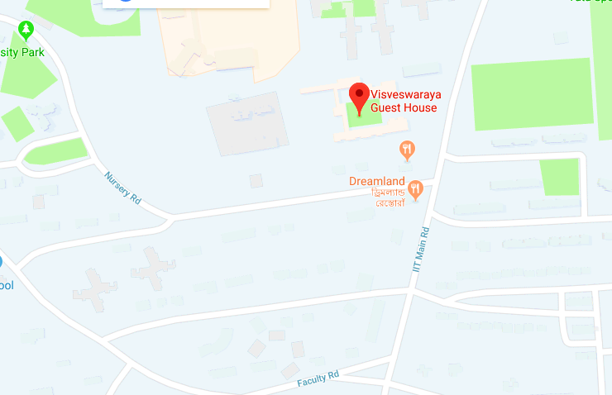Description: Road stretch between Visveswaraya Guest House and Prem Bazar Gate (before the second speed bump)

Date of Survey: 13 August, 2018

Time of survey: 2:30 p.m. – 4:30 p.m.

Weather Conditions: Overcast Sky, Drizzling

Traffic Conditions: Free Flow – Very Light to Light Vehicular Flow

Posted Speed Limit: 40 km/hr

Instrument Used: Laser Speed Gun

**PHOTOS OF LOCATION-**

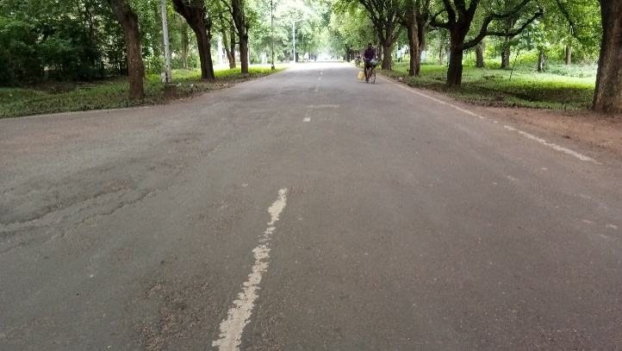

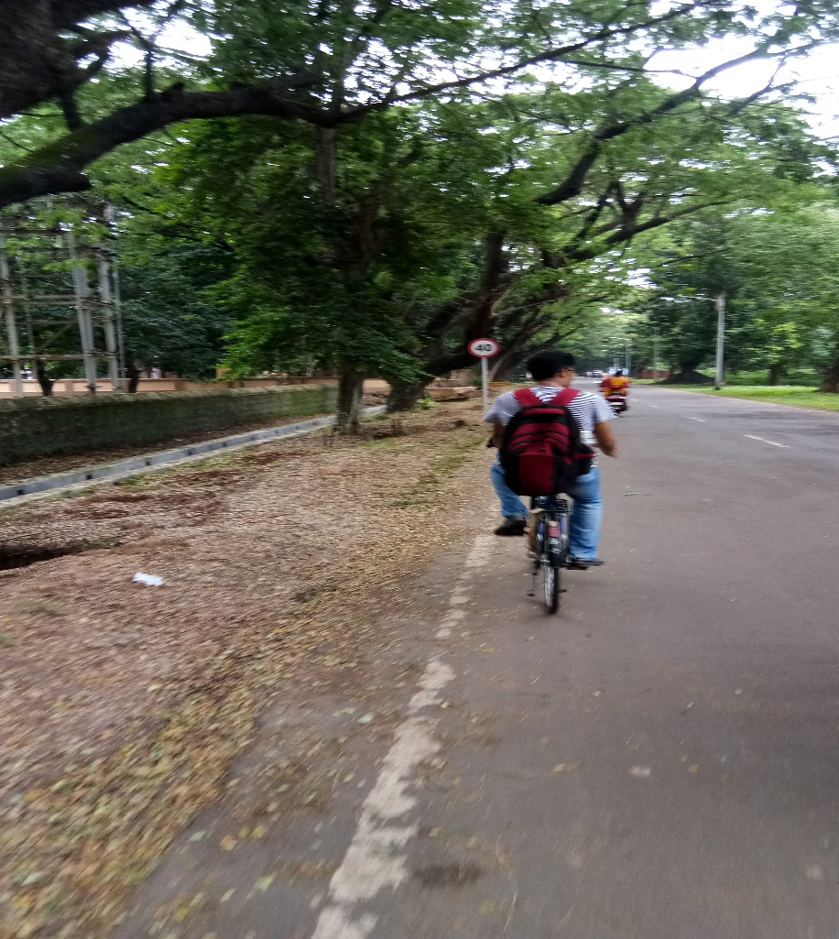

*(Board showing maximum speed of 40km/h)*

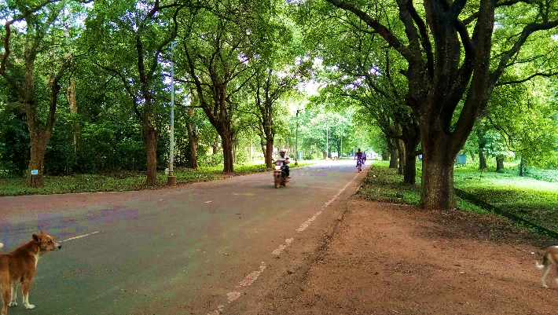

1. **ANALYSIS OF RECORDED DATA:**

The data was differentiated based on vehicle type:

1. Data for Motorbikes
2. Data for Cars

The recorded data are as follows:

1. **CALCULATIONS ON COLLECTED DATA**
   1. **MOTORBIKES**

|  |  |  |  |  |  |  |
| --- | --- | --- | --- | --- | --- | --- |
| **Data collection for Spot-Speed Study Experiment (MOTORBIKE)** | | | | | | |
| **Serial No.** | **Higher Speed** | **Mid Speed** | **Lower Speed** | **Frequency** | **Frequency (%)** | **Cumulative Frequency (%)** |
| 1 | 19.5 | 20 | 20.5 | 4 | 4.4943 | 4.4943 |
| 2 | 20.5 | 21 | 21.5 | 3 | 3.3707 | 7.865 |
| 3 | 21.5 | 22 | 22.5 | 4 | 4.4943 | 12.3593 |
| 4 | 22.5 | 23 | 23.5 | 3 | 3.3707 | 15.73 |
| 5 | 23.5 | 24 | 24.5 | 2 | 2.2471 | 17.9771 |
| 6 | 24.5 | 25 | 25.5 | 6 | 6.7415 | 24.7186 |
| 7 | 25.5 | 26 | 26.5 | 4 | 4.4943 | 29.2129 |
| 8 | 26.5 | 27 | 27.5 | 3 | 3.3707 | 32.5836 |
| 9 | 27.5 | 28 | 28.5 | 2 | 2.2471 | 34.8307 |
| 10 | 28.5 | 29 | 29.5 | 3 | 3.3707 | 38.2014 |
| 11 | 29.5 | 30 | 30.5 | 3 | 3.3707 | 41.5721 |
| 12 | 30.5 | 31 | 31.5 | 3 | 3.3707 | 44.9428 |
| 13 | 31.5 | 32 | 32.5 | 3 | 3.3707 | 48.3135 |
| 14 | 32.5 | 33 | 33.5 | 4 | 4.4943 | 52.8078 |
| 15 | 33.5 | 34 | 34.5 | 6 | 6.7415 | 59.5493 |
| 16 | 34.5 | 35 | 35.5 | 2 | 2.2471 | 61.7964 |
| 17 | 35.5 | 36 | 36.5 | 5 | 5.6179 | 67.4143 |
| 18 | 36.5 | 37 | 37.5 | 2 | 2.2471 | 69.6614 |
| 19 | 37.5 | 38 | 38.5 | 5 | 5.6179 | 75.2793 |
| 20 | 38.5 | 39 | 39.5 | 2 | 2.2471 | 77.5264 |
| 21 | 39.5 | 40 | 40.5 | 2 | 2.2471 | 79.7735 |
| 22 | 40.5 | 41 | 41.5 | 3 | 3.3707 | 83.1442 |
| 23 | 41.5 | 42 | 42.5 | 1 | 1.1235 | 84.2677 |
| 24 | 42.5 | 43 | 43.5 | 3 | 3.3707 | 87.6384 |
| 25 | 43.5 | 44 | 44.5 | 1 | 1.1235 | 88.7619 |
| 26 | 44.5 | 45 | 45.5 | 2 | 2.2471 | 91.009 |
| 27 | 45.5 | 46 | 46.5 | 3 | 3.3707 | 94.3797 |
| 28 | 46.5 | 47 | 47.5 | 1 | 1.1235 | 95.5032 |
| 29 | 47.5 | 48 | 48.5 | 1 | 1.1235 | 96.6267 |
| 30 | 48.5 | 49 | 49.5 | 3 | 3.3707 | 99.9974 |

* 1. **CARS**

|  |  |  |  |  |  |  |
| --- | --- | --- | --- | --- | --- | --- |
| **Data collection for Spot-Speed Study Experiment (CAR)** | | | | | | |
| **Serial No.** | **Higher Speed** | **Mid Speed** | **Lower Speed** | **Frequency** | **Frequency (%)** | **Cumulative Frequency (%)** |
| 1 | 19.5 | 20 | 20.5 | 4 | 8.16% | 8.16% |
| 2 | 20.5 | 21 | 21.5 | 1 | 2.04% | 10.20% |
| 3 | 21.5 | 22 | 22.5 | 4 | 8.16% | 18.37% |
| 4 | 22.5 | 23 | 23.5 | 3 | 6.12% | 24.49% |
| 5 | 23.5 | 24 | 24.5 | 1 | 2.04% | 26.53% |
| 6 | 24.5 | 25 | 25.5 | 1 | 2.04% | 28.57% |
| 7 | 25.5 | 26 | 26.5 | 3 | 6.12% | 34.69% |
| 8 | 26.5 | 27 | 27.5 | 1 | 2.04% | 36.73% |
| 9 | 27.5 | 28 | 28.5 | 2 | 4.08% | 40.82% |
| 10 | 28.5 | 29 | 29.5 | 1 | 2.04% | 42.86% |
| 11 | 29.5 | 30 | 30.5 | 1 | 2.04% | 44.90% |
| 12 | 30.5 | 31 | 31.5 | 2 | 4.08% | 48.98% |
| 13 | 31.5 | 32 | 32.5 | 1 | 2.04% | 51.02% |
| 14 | 32.5 | 33 | 33.5 | 2 | 4.08% | 55.10% |
| 15 | 33.5 | 34 | 34.5 | 3 | 6.12% | 61.22% |
| 16 | 34.5 | 35 | 35.5 | 1 | 2.04% | 63.27% |
| 17 | 35.5 | 36 | 36.5 | 2 | 4.08% | 67.35% |
| 18 | 36.5 | 37 | 37.5 | 2 | 4.08% | 71.43% |
| 19 | 37.5 | 38 | 38.5 | 1 | 2.04% | 73.47% |
| 20 | 38.5 | 39 | 39.5 | 1 | 2.04% | 75.51% |
| 21 | 39.5 | 40 | 40.5 | 4 | 8.16% | 83.67% |
| 22 | 40.5 | 41 | 41.5 | 2 | 4.08% | 87.76% |
| 23 | 41.5 | 42 | 42.5 | 2 | 4.08% | 91.84% |
| 24 | 42.5 | 43 | 43.5 | 3 | 6.12% | 97.96% |
| 25 | 43.5 | 44 | 44.5 | 0 | 0.00% | 97.96% |
| 26 | 44.5 | 45 | 45.5 | 0 | 0.00% | 97.96% |
| 27 | 45.5 | 46 | 46.5 | 1 | 2.04% | 100.00% |
| 28 | 46.5 | 47 | 47.5 | 0 | 0.00% | 100.00% |
| 29 | 47.5 | 48 | 48.5 | 0 | 0.00% | 100.00% |
| 30 | 48.5 | 49 | 49.5 | 0 | 0.00% | 100.00% |

1. **RESULTS**

|  |  |  |  |  |  |
| --- | --- | --- | --- | --- | --- |
| **RESULTS** | | | | | |
| **MOTORBIKE** | | | **CAR** | | |
| **Mid Speed** | **Frequency (%)** | **Cumulative Frequency (%)** | **Mid Speed** | **Frequency (%)** | **Cumulative Frequency (%)** |
| 20 | 4.4943 | 4.4943 | 20 | 8.16% | 8.16% |
| 21 | 3.3707 | 7.865 | 21 | 2.04% | 10.20% |
| 22 | 4.4943 | 12.3593 | 22 | 8.16% | 18.37% |
| 23 | 3.3707 | 15.73 | 23 | 6.12% | 24.49% |
| 24 | 2.2471 | 17.9771 | 24 | 2.04% | 26.53% |
| 25 | 6.7415 | 24.7186 | 25 | 2.04% | 28.57% |
| 26 | 4.4943 | 29.2129 | 26 | 6.12% | 34.69% |
| 27 | 3.3707 | 32.5836 | 27 | 2.04% | 36.73% |
| 28 | 2.2471 | 34.8307 | 28 | 4.08% | 40.82% |
| 29 | 3.3707 | 38.2014 | 29 | 2.04% | 42.86% |
| 30 | 3.3707 | 41.5721 | 30 | 2.04% | 44.90% |
| 31 | 3.3707 | 44.9428 | 31 | 4.08% | 48.98% |
| 32 | 3.3707 | 48.3135 | 32 | 2.04% | 51.02% |
| 33 | 4.4943 | 52.8078 | 33 | 4.08% | 55.10% |
| 34 | 6.7415 | 59.5493 | 34 | 6.12% | 61.22% |
| 35 | 2.2471 | 61.7964 | 35 | 2.04% | 63.27% |
| 36 | 5.6179 | 67.4143 | 36 | 4.08% | 67.35% |
| 37 | 2.2471 | 69.6614 | 37 | 4.08% | 71.43% |
| 38 | 5.6179 | 75.2793 | 38 | 2.04% | 73.47% |
| 39 | 2.2471 | 77.5264 | 39 | 2.04% | 75.51% |
| 40 | 2.2471 | 79.7735 | 40 | 8.16% | 83.67% |
| 41 | 3.3707 | 83.1442 | 41 | 4.08% | 87.76% |
| 42 | 1.1235 | 84.2677 | 42 | 4.08% | 91.84% |
| 43 | 3.3707 | 87.6384 | 43 | 6.12% | 97.96% |
| 44 | 1.1235 | 88.7619 | 44 | 0.00% | 97.96% |
| 45 | 2.2471 | 91.009 | 45 | 0.00% | 97.96% |
| 46 | 3.3707 | 94.3797 | 46 | 2.04% | 100.00% |
| 47 | 1.1235 | 95.5032 | 47 | 0.00% | 100.00% |
| 48 | 1.1235 | 96.6267 | 48 | 0.00% | 100.00% |
| 49 | 3.3707 | 99.9974 | 49 | 0.00% | 100.00% |

1. **GRAPHICAL REPRESENTATION OF DATA**
   1. **MOTORBIKES**
   2. **CARS**
2. **STATISTICAL CALCULATIONS ON DATA:**

For further analysis of data, statistical measures are applied on the data.

The statistical indicators which would reflect a change in traffic flow are as follows:

1. Mean Speed – The average speed; Calculated as the sum of all speeds divided by the number of speed observations.
2. Median Speed or 50th Percentile Speed – The speed that equally divides the distribution of spot speeds; 50 percent of observed speeds are higher than the median; 50 percent of observed speeds are lower than the median.
3. 85th Percentile Speed – The speed at or below which 85 percent of a sample of free flowing vehicles is travelling; this is typically used as a baseline for establishing the operating speed.
4. 15th Percentile Speed – The speed at or below which 15 percent of a sample of free flowing vehicles is travelling.
5. 98th Percentile Speed – The speed at or below which 98 percent of a sample of free flowing vehicles is travelling
6. Mode Speed – The number that occurs most frequently in a series of numbers.
7. Range – The difference between the smallest and the largest reading in a sample
8. Standard Deviation – The difference in travel speeds for vehicles on the road. Variance is the average of the squares of the difference to the mean for each observed speed. Standard Deviation is the square root of Variance.
9. Standard Error of Mean –The standard error of the mean (SEM) depicts the dispersion of sample means around the population mean.

where, σ is the [standard deviation](https://en.wikipedia.org/wiki/Standard_deviation) & n is the size of the sample

A C-code has been developed to determine the mean, median, 85th, 98th percentile speed, variance, and standard deviation:

#include<stdio.h>

#include<math.h>

int n;

float speed_data[100];

intfrequency[100];

float sum_of_speed=0,mean_speed,variance,standard_deviation;

intsum_freq=0;

void f_mean()

{

inti;

for(i=0;i<n;i++)

{

sum_of_speed+=speed_data[i]*frequency[i];

sum_freq+=frequency[i];

}

mean_speed=sum_of_speed/sum_freq;

printf("%4.2f\n",mean_speed);

}

void f_var()

{

inti;

float temp_var=0;

for(i=0;i<n;i++)

{

temp_var+=(speed_data[i]-mean_speed)*(speed_data[i]-mean_speed)*frequency[i];

}

variance=temp_var/sum_freq;

standard_deviation=sqrt(variance);

printf("%4.2f\n",variance);

}

void f_percentile()

{

inti,j,k,temp_var=0;

float m,percentile_50,percentile_85,percentile_98;

for(i=0;i<n;i++)

{

if((temp_var+frequency[i])>=(sum_freq*0.5))

{

break;

}

temp_var+=frequency[i];

}

m=(speed_data[i]-speed_data[i-1])/(frequency[i]);

percentile_50=speed_data[i-1] + m*(sum_freq*0.5-temp_var);

printf("%4.2f\n",percentile_50);

for(j=i+1;j<n;j++)

{

if(temp_var+frequency[j]>=(sum_freq*0.85))

{

break;

}

temp_var+=frequency[j];

}

m=(speed_data[j]-speed_data[j-1])/(frequency[j]);

percentile_85=speed_data[j-1] + m*(0.85*sum_freq-temp_var);

printf("%4.2f\n",percentile_85);

for(k=j+1;k<n;k++)

{

if(temp_var+frequency[k]>=(sum_freq*0.98))

{

break;

}

temp_var+=frequency[k];

}

m=(speed_data[k]-speed_data[k-1])/(frequency[k]);

percentile_98=speed_data[k-1] + m*(0.98*sum_freq-temp_var);

printf("%4.2f\n",percentile_98);

}

intmain()

{

FILE *f,*s;

f=fopen("f.txt","r");

if(f==NULL)

{

printf("error\n");

return;

}

s=fopen("s.txt","r");

if(s==NULL)

{

printf("error\n");

return;

}

printf("enter number of entries\n");

scanf("%d",&n);

inti;

for(i=0;i<n;i++)

{

fscanf(s,"%f",&speed_data[i]);

fscanf(f,"%d",&frequency[i]);

}

f_mean();

f_var();

f_percentile();

}

**Calculations –**

|  |  |  |
| --- | --- | --- |
| **Statistical Measure** | **Vehicle** | |
| **Motorbike** | **Car** |
| **Sample Size** | 89 | 49 |
| **Minimum Speed (KMPH)** | 20.0 | 20.0 |
| **Maximum Speed (KMPH)** | 49.0 | 46.0 |
| **Range (KMPH)** | 29.0 | 26.0 |
| **Mean Speed (KMPH)** | 32.82 | 31.71 |
| **Median Speed (KMPH)** | 32.51 | 31.50 |
| **85th Percentile Speed (KMPH)** | 42.24 | 40.56 |
| **15th Percentile Speed (KMPH)** | 22.88 | 21.76 |
| **98th Percentile Speed (KMPH)** | 48.23 | 45.50 |
| **Mode Speed (KMPH)** | NA | NA |
| **Standard Deviation (KMPH)** | 14.65 | 12.51 |
| **Standard Error (KMPH)** | 1.552 | 1.787 |

**Some Observations –**

* 1. Number of bikes passing through the location is more as compared to number of cars.
  2. Mean Speed, Median Speed, 85th percentile Speed are approximately same for Motorbikes and Cars.

1. **CONCLUSION:**
2. The posted Speed Limit is 40 km/hr which is followed by almost all vehicles as 85th percentile Speed is near to 40 km/hr.
3. We observed no Accident Prone Areas. This was mostly because during the time of conduction the vehicular traffic was very low.